Achilles drags the body of Hector and Thetis Plunges Achilles in River Styx
Pen, brown ink, wash and watercolour on laid paper, within a framing line in pen and brown ink. In later frames.
Attributed to Felice Giani (1758–1823)
Circa 1820

Each measuring: Framed:
Height: 8,34 in. (21,2 cm) Height: 10,62 in. (27 cm)
Width: 16,53 in. (42 cm) Width: 18,7 in. (47,5 cm)

Literature:
A. Ottani Cavina, Felice Giani 1758–1823 e la cultura di fine secolo, Milan, Electa, 1997, p.197 (illustrated).
L. Dickinson Michaux, Visions of Antiquity: Neoclassical Figure Drawings, Los Angeles County Museum of Art and The Minneapolis Institute of Arts, 1993, p. 280.

The present pair of drawings shows two episodes from the life of the Greek hero Achilles. In one, the infant Achilles is immersed in the waters of the river Styx by his mother, the Nymph Thetis. The waters of the river will make Achilles immortal. As the drawing shows, however, Thetis did not immerge all of Achilles’ body. She left out his heel, by which she was holding him. This will remain Achilles’ most vulnerable body part – hence the phrase ‘Achilles’ heel’.
The other drawing shows an episode from the war of Troy. After having killed Hector, the son of the king of Troy, Achilles has his enemy’s body tied to his carriage and drags him in the planes surrounding the city to further humiliate the Trojans.

Giani treated the same subjects several times. The most ambitious example is the series of frescoes in the Hall of Palazzo Milzetti in Faneza, also known as Galleria di Achille (Gallery of Achilles) dating to c. 1790 (fig.1). Similar sketches on paper survive in the Cooper Hewitt Museum in Washington, DC and in the Gabinetto delle Stampe e dei Disegni di Palazzo Braschi in Rome (figs.2–5).

The very fluid, confident and economic use of the pen, the stylised rendering of the figures (especially the faces) and the savvy use of wash suggest that these might be a later exploration of the themes so dear to the artist, rather than preparatory drawings for the frescoes, dating probably from the late 1810s or early 1820s. If not by Giani, they may be by one of Giani’s most talented pupils, such as Gaetano Bertolani or Michael Kock.

Felice Giani (San Sebastiano Curone 1758–1823 Rome)
Giani studied under the most illustrious artists of his generation. He began his artistic training in Pavia under Carlo Bianchi and Antonio Galli Bibiena. In 1778 he moved to Bologna to study with Domenico Pedrini and Ubaldo Gandolfi. Between 1780 and 1786 he moved to Rome, studying with Pompeo Batoni, Giuseppe Antolini, and Christoph Unterberger at the Accademia di San Luca. During this time, he won a prize for painting at the Accademia and a second prize from the Accademia di Belle Arti di Parma for his Samson and Delilah.
Giani became one of the most popular artists of the turn of the century, realising large fresco cycles in Forli, Venice, Ravenna, Ariccia, Bologna, Faenza, and Rome. His reputation was not limited to the Italian peninsula, however. In 1788 he worked for Catherine II of Russia in Saint Petersburg, and in 1803 he moved to Paris on Napoleon’s invitation, working on frescoes at the Tuilleries and Malmaison palaces. In 1805 he settled more or less permanently in Rome and contributed to the decoration of the Palazzo di Spagna in 1806 and the Palazzo Quirinale in 1812–13. He was elected a member of the Accademia di San Luca in 1811 and to the Congregazione dei Virtuosi del Pantheon in 1819. His last large decorative project was the Teatro della Valle in Rome in 1821.

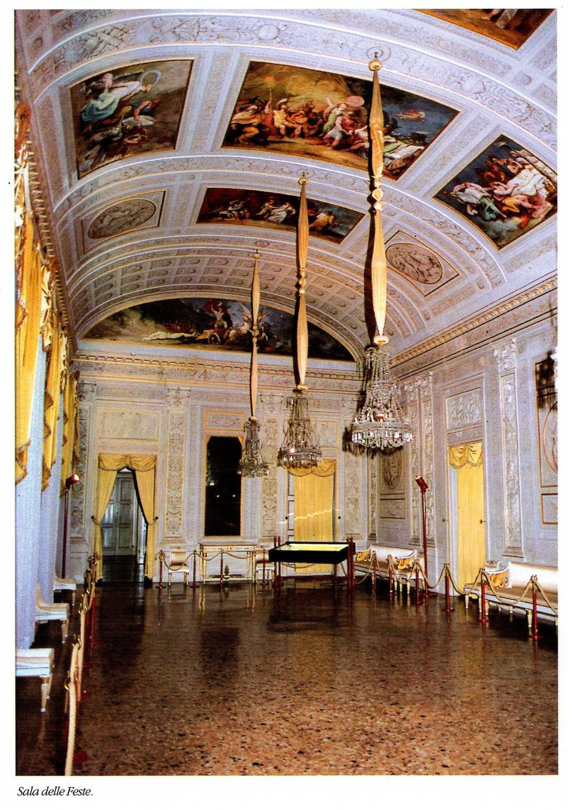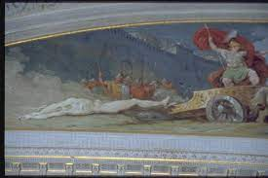
Fig.1 Salone delle Feste or Galleria di Achille in Palazzo Milzetti, Faenza, c.1790 and detail of Fig.1, showing ones of Giani’s frescoes depicting Achilles dragging the body of Hector.

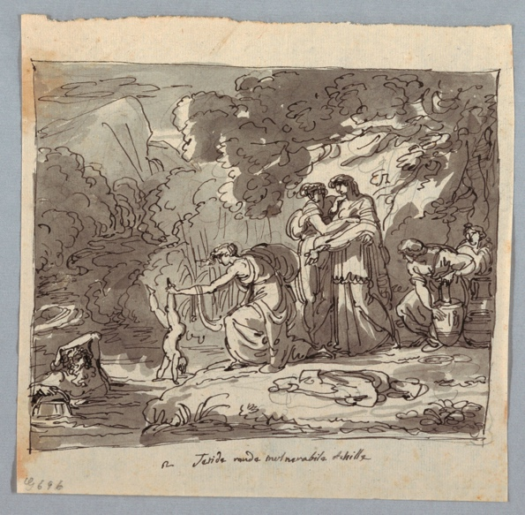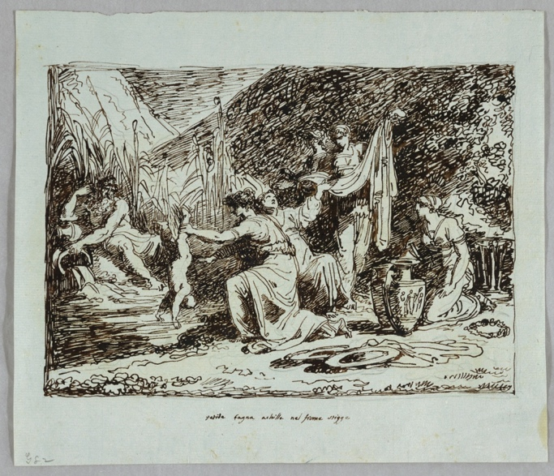
Figs.2–3 Felice Giani, Thetis and Achilles, The Coper Hewitt Smithsonian Design Museum, inv. nos.1901-39-3443 and 1901-39-3288.

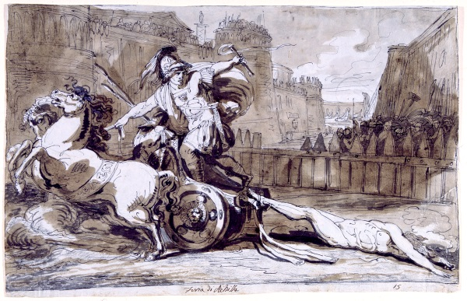
Fig.4 Felice Giani, Achilles and Hector, Museo di Roma, Gabinetto delle Stampe e dei Disegni di Palazzo Braschi, inv. no. MR13510.

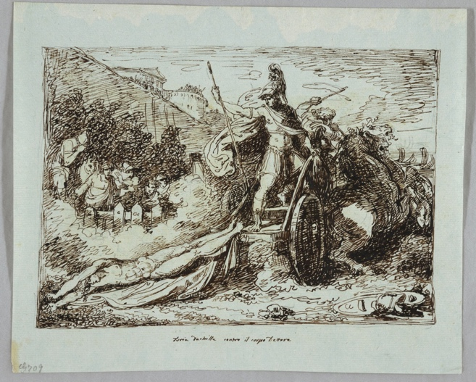
Fig.5 Felice Giani, Achilles and Hector, the Coper Hewitt Smithsonian Design Museum, inv. no. 1901-39-3292.

